# Influence of degree of compaction on arsenic and antimony co-contaminated soil stabilization: Geoenvironmental properties and chemical species

Shi-Ji Zhou

Ph.D. Student, Jiangsu Key Laboratory of Urban Underground Engineering & Environmental Safety, Institute of Geotechnical Engineering, Southeast University, Nanjing 211189, China. Email: [shijizhou@seu.edu.cn](mailto:shijizhou@seu.edu.cn)

Ya-Song Feng

Postdoctoral Researcher, Jiangsu Province Key Laboratory of Environmental Engineering, Jiangsu Provincial Academy of Environmental Science, Nanjing 210036, China. Email: [fengyasong@seu.edu.cn](mailto:fengyasong@seu.edu.cn).

Yan-Jun Du

Professor, Jiangsu Key Laboratory of Urban Underground Engineering & Environmental Safety, Institute of Geotechnical Engineering, Southeast University, Nanjing 211189, China. Email: [duyanjun@seu.edu.cn](mailto:duyanjun@seu.edu.cn) (**Corresponding author**)

Guang-Yu Yang

Master Candidate, Jiangsu Key Laboratory of Urban Underground Engineering & Environmental Safety, Institute of Geotechnical Engineering, Southeast University, Nanjing 211189, China. Email: [220193259@seu.edu.cn](mailto:220193259@seu.edu.cn)

Hui-Yang Sun

Master Candidate, Jiangsu Key Laboratory of Urban Underground Engineering & Environmental Safety, Institute of Geotechnical Engineering, Southeast University, Nanjing 211189, China. Email: [220193200@seu.edu.cn](mailto:220193200@seu.edu.cn)

Qing Zhang

Master Candidate, Jiangsu Key Laboratory of Urban Underground Engineering & Environmental Safety, Institute of Geotechnical Engineering, Southeast University, Nanjing 211189, China. Email: [220203222@seu.edu.cn](mailto:220203222@seu.edu.cn)

Yang Hu

Master Candidate, Jiangsu Key Laboratory of Urban Underground Engineering & Environmental Safety, Institute of Geotechnical Engineering, Southeast University, Nanjing 211189, China. Email: [seuhy@seu.edu.cn](mailto:seuhy@seu.edu.cn)

Table S1 Physical and chemical properties of contaminated soil used in this study

|  |  |
| --- | --- |
| Property | Values |
| Moisture content *w* (%) | 22.7 |
| Specific gravity *G*s | 2.64 |
| Plastic limit *w*P (%) | 30.4 |
| Liquid limit *w*L (%) | 41.4 |
| Optimum moisture content *w*opt (%) | 16.4 |
| Maximum dry density *ρ*d (g·cm-3) | 1.74 |
| pH value | 5.68 |
| Particle size distribution (%) |  |
| Clay | 24.8 |
| Silt | 66.9 |
| Sand | 8.3 |
| Metal or metalloid content  Fe (g·kg-1)  As (mg·kg-1)  Sb (mg·kg-1) | 6.21 ± 0.37  6547 ± 362  2420 ± 217 |

Table S2 Chemical compositions of contaminated soil used in this study determined by X-ray fluorescence spectrometer (XRF)

|  |  |
| --- | --- |
| Oxide | Content (%) |
| Silicon oxide (SiO2) | 66.77 |
| Aluminum oxide (Al2O3) | 12.95 |
| Ferric oxide (Fe2O3) | 4.89 |
| Calcium oxide (CaO) | 2.52 |
| Potassium oxide (K2O) | 1.13 |
| Magnesium oxide (MgO) | 1.11 |
| Titanium dioxide (TiO2) | 0.74 |
| Manganese oxide (MnO) | 0.34 |
| Sulfur trioxide (SO3) | 0.28 |
| Loss on ignition (950℃) | 8.48 |

Table S3 Sample information for various tests

|  |  |  |  |  |  |
| --- | --- | --- | --- | --- | --- |
| Property test | Size (*d* mm × *h* mm ) | PFSC dosage (%) | Degree of compaction (%) | Curing time (d) | Number |
| UCS | 50 × 100 | 4 | 75%, 80%, 85%, 90%, 93%, 96% | 14 | 3 |
| *k*w | 50 × 50 | 4 | 75%, 80%, 85%, 90%, 93%, 96% | 14 | 1 |
| Batch leaching test | Particle | 4 | 75%, 80%, 85%, 90%, 93%, 96% | 14 | 3 |
| Soil pH | Powder | 4 | 75%, 80%, 85%, 90%, 93%, 96% | 14 | 3 |
| Soil Eh | Powder | 4 | 75%, 80%, 85%, 90%, 93%, 96% | 14 | 3 |
| Semi-dynamic leaching test | 50 × 60 | 4 | 75%, 80%, 85%, 90%, 93%, 96% | 14 | 1 |
| CT scanning | 50 × 50 | 4 | 75%, 80%, 85%, 90%, 93%, 96% | 14 | 1 |
| XPS analysis | Powder | 4 | 75%, 90%, 96% | 14 | 1 |

Table S4 The cumulative fractions (%) of As and Sb leached from PFSC stabilized contaminated soil specimens compacted with different degrees.

|  |  |  |
| --- | --- | --- |
| Degree of compaction | Cumulative fraction of As leached (%) | Cumulative fraction of Sb leached (%) |
| 75% | 0.76 | 0.32 |
| 80% | 0.34 | 0.24 |
| 85% | 0.18 | 0.20 |
| 90% | 0.051 | 0.053 |
| 93% | 0.036 | 0.036 |
| 96% | 0.028 | 0.024 |

Table S5 Regression analysis parameters, controlled mechanism, and observed diffusivity (*D*obs) for As and Sb released from 4% PFSC stabilized contaminated soil specimen compacted with degree of 75%

|  |  |  |  |  |  |  |
| --- | --- | --- | --- | --- | --- | --- |
| Leaching interval | As | | | Sb | | |
| Slope | Controlled mechanism | *D*obs (m2 s-1) | Slope | Controlled mechanism | *D*obs (m2 s-1) |
| 1 | 0.05 | Wash-off | — | 0.15 | Wash-off | — |
| 2 | 0.71 | Dissolution | — | 1.36 | Dissolution | — |
| 3 | 0.23 | Wash-off | — | 0.28 | Wash-off | — |
| 4 | 0.85 | Dissolution | — | 0.52 | Diffusion | 3.15 × 10-9 |
| 5 | 0.62 | Diffusion | 1.92 × 10-8 | 0.51 | Diffusion | 2.12 × 10-9 |
| 6 | 0.91 | Dissolution | — | 0.71 | Dissolution | — |
| 7 | 1.72 | Dissolution | — | 1.25 | Dissolution | — |
| 8 | 0.69 | Dissolution | — | 0.76 | Dissolution | — |

Table S6 Regression analysis parameters, controlled mechanism, and observed diffusivity (*D*obs) for As and Sb released from 4% PFSC stabilized contaminated soil specimen compacted with degree of 80%

|  |  |  |  |  |  |  |
| --- | --- | --- | --- | --- | --- | --- |
| Leaching interval | As | | | Sb | | |
| Slope | Controlled mechanism | *D*obs (m2 s-1) | Slope | Controlled mechanism | *D*obs (m2 s-1) |
| 1 | 0.06 | Wash-off | — | 0.11 | Wash-off | — |
| 2 | 0.62 | Diffusion | 8.89 × 10-9 | 1.42 | Dissolution | — |
| 3 | 0.18 | Wash-off | — | 0.29 | Wash-off | — |
| 4 | 0.53 | Diffusion | 3.14 × 10-9 | 0.59 | Diffusion | 2.90 × 10-9 |
| 5 | 0.44 | Diffusion | 2.12 × 10-9 | 0.35 | Diffusion | 9.66 × 10-10 |
| 6 | 0.75 | Dissolution | — | 0.67 | Dissolution | — |
| 7 | 1.75 | Dissolution | — | 1.58 | Dissolution | — |
| 8 | 0.95 | Dissolution | — | 0.67 | Dissolution | — |

Table S7 Regression analysis parameters, controlled mechanism, and observed diffusivity (*D*obs) for As and Sb released from 4% PFSC stabilized contaminated soil specimen compacted with degree of 85%

|  |  |  |  |  |  |  |
| --- | --- | --- | --- | --- | --- | --- |
| Leaching interval | As | | | Sb | | |
| Slope | Controlled mechanism | *D*obs (m2 s-1) | Slope | Controlled mechanism | *D*obs (m2 s-1) |
| 1 | 0.07 | Wash-off | — | 0.13 | Wash-off | — |
| 2 | 0.65 | Diffusion | 2.66 × 10-9 | 1.22 | Dissolution | — |
| 3 | 0.19 | Wash-off | — | 0.36 | Diffusion | 6.41 × 10-9 |
| 4 | 0.58 | Diffusion | 1.13 × 10-9 | 0.63 | Diffusion | 2.00 × 10-9 |
| 5 | 0.37 | Diffusion | 4.39 × 10-10 | 0.34 | Wash-off | 5.75 × 10-10 |
| 6 | 0.80 | Dissolution | — | 0.72 | Dissolution | — |
| 7 | 1.86 | Dissolution | — | 1.63 | Dissolution | — |
| 8 | 0.75 | Dissolution | — | 0.68 | Dissolution | — |

Table S8 Regression analysis parameters, controlled mechanism, and observed diffusivity (*D*obs) for As and Sb released from 4% PFSC stabilized contaminated soil specimen compacted with degree of 90%

|  |  |  |  |  |  |  |
| --- | --- | --- | --- | --- | --- | --- |
| Leaching interval | As | | | Sb | | |
| Slope | Controlled mechanism | *D*obs (m2 s-1) | Slope | Controlled mechanism | *D*obs (m2 s-1) |
| 1 | 0.09 | Wash-off | — | 0.11 | Wash-off | — |
| 2 | 0.86 | Dissolution | 1.78 × 10-10 | 1.08 | Dissolution | — |
| 3 | 0.46 | Diffusion | 5.53 × 10-10 | 0.40 | Diffusion | 6.04 × 10-10 |
| 4 | 0.63 | Diffusion | 1.22 × 10-10 | 0.57 | Diffusion | 1.26 × 10-10 |
| 5 | 0.42 | Diffusion | 5.40 × 10-11 | 0.40 | Diffusion | 6.21 × 10-11 |
| 6 | 0.80 | Dissolution | — | 0.58 | Diffusion | 2.39 × 10-11 |
| 7 | 1.37 | Dissolution | — | 1.45 | Dissolution | — |
| 8 | 0.69 | Dissolution | — | 0.78 | Dissolution | — |

Table S9 Regression analysis parameters, controlled mechanism, and observed diffusivity (*D*obs) for As and Sb released from 4% PFSC stabilized contaminated soil specimen compacted with degree of 93%

|  |  |  |  |  |  |  |
| --- | --- | --- | --- | --- | --- | --- |
| Leaching interval | As | | | Sb | | |
| Slope | Controlled mechanism | *D*obs (m2 s-1) | Slope | Controlled mechanism | *D*obs (m2 s-1) |
| 1 | 0.08 | Wash-off | — | 0.59 | Diffusion | 6.49 × 10-10 |
| 2 | 1.04 | Dissolution | — | 0.85 | Dissolution | — |
| 3 | 0.50 | Diffusion | 4.22 × 10-10 | 0.37 | Diffusion | 3.67 × 10-10 |
| 4 | 0.47 | Diffusion | 4.07 × 10-11 | 0.41 | Diffusion | 4.08 × 10-11 |
| 5 | 0.46 | Diffusion | 3.66 × 10-11 | 0.43 | Diffusion | 3.95 × 10-11 |
| 6 | 0.63 | Diffusion | 1.13 × 10-11 | 0.48 | Diffusion | 8.82 × 10-12 |
| 7 | 1.39 | Dissolution | — | 1.20 | Dissolution | — |
| 8 | 0.66 | Dissolution | — | 0.67 | Dissolution | — |

Table S10 Regression analysis parameters, controlled mechanism, and observed diffusivity (*D*obs) for As and Sb released from 4% PFSC stabilized contaminated soil specimen compacted with degree of 96%

|  |  |  |  |  |  |  |
| --- | --- | --- | --- | --- | --- | --- |
| Leaching interval | As | | | Sb | | |
| Slope | Controlled mechanism | *D*obs (m2 s-1) | Slope | Controlled mechanism | *D*obs (m2 s-1) |
| 1 | 0.06 | Wash-off | — | 0.07 | Wash-off | — |
| 2 | 0.96 | Dissolution | — | 0.91 | Dissolution | — |
| 3 | 0.42 | Diffusion | 2.16 × 10-10 | 0.41 | Diffusion | 2.11 × 10-10 |
| 4 | 0.44 | Diffusion | 2.24 × 10-11 | 0.30 | Diffusion | 1.01 × 10-11 |
| 5 | 0.47 | Diffusion | 2.42 × 10-11 | 0.45 | Diffusion | 1.81 × 10-11 |
| 6 | 0.58 | Diffusion | 6.94 × 10-12 | 0.45 | Diffusion | 3.38 × 10-12 |
| 7 | 0.46 | Dissolution | 4.06 × 10-12 | 0.43 | Diffusion | 2.05 × 10-12 |
| 8 | 0.65 | Diffusion | 5.52 × 10-12 | 0.63 | Diffusion | 1.14 × 10-12 |

Table S11 The ratios of As(III) and As(V), Sb(III) and Sb(V), and Fe(II) and Fe(III) to total As, total Sb, and total Fe existed in PFSC stabilized contaminated soil samples compacted with degrees of 75%, 90%, and 96%, respectively.

|  |  |  |  |  |  |  |  |  |  |
| --- | --- | --- | --- | --- | --- | --- | --- | --- | --- |
| Degree of compaction | Arsenic (As) | | | Antimony (Sb) | | | Iron (Fe) | | |
| As(III) (%) | As(V) (%) | As(V)/As(III) | Sb(III) (%) | Sb(V) (%) | Sb(V)/Sb(III) | Fe(II) (%) | Fe(III) (%) | Fe(III)/Fe(II) |
| 75% | 24.4 | 75.6 | 3.10 | 15.5 | 84.5 | 5.45 | 25.7 | 74.3 | 2.89 |
| 90% | 41.9 | 58.1 | 1.39 | 24.3 | 75.7 | 3.11 | 31.4 | 68.6 | 2.18 |
| 96% | 52.8 | 47.2 | 0.89 | 28.4 | 71.6 | 2.52 | 35.6 | 64.4 | 1.81 |

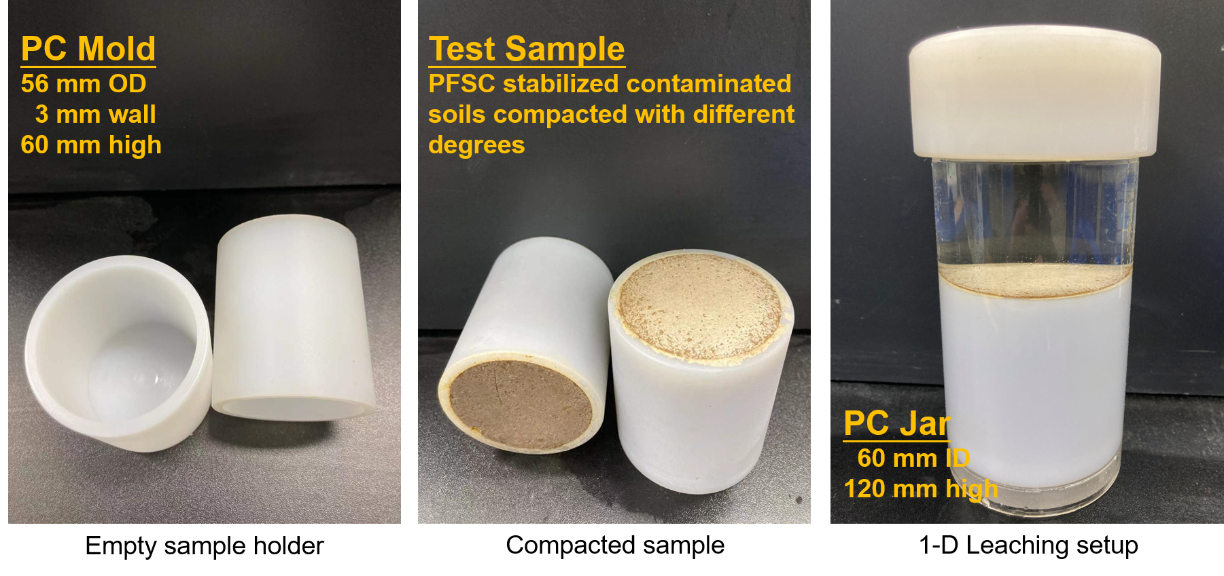

Fig. S1. Holder and setup used in semi-dynamic leaching test for PFSC stabilized contaminated soil specimens compacted with different degrees.





Fig. S2. Leached concentrations of (a) As and (b) Sb from PFSC stabilized contaminated soil specimens compacted with different degrees. Semi-leaching test method: US EPA Method 1315.

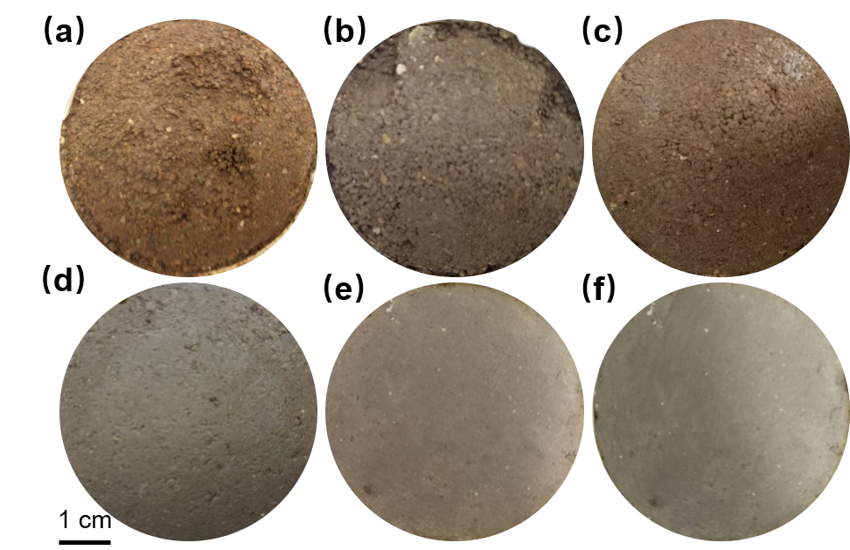

Fig. S3 Upper surface pictures of the PFSC stabilized contaminated soil specimens compacted with degrees of (a) 75%, (b) 80%, (c) 85%, (d) 90%, (e) 93%, and (d) 96% after semi-dynamic leaching test.

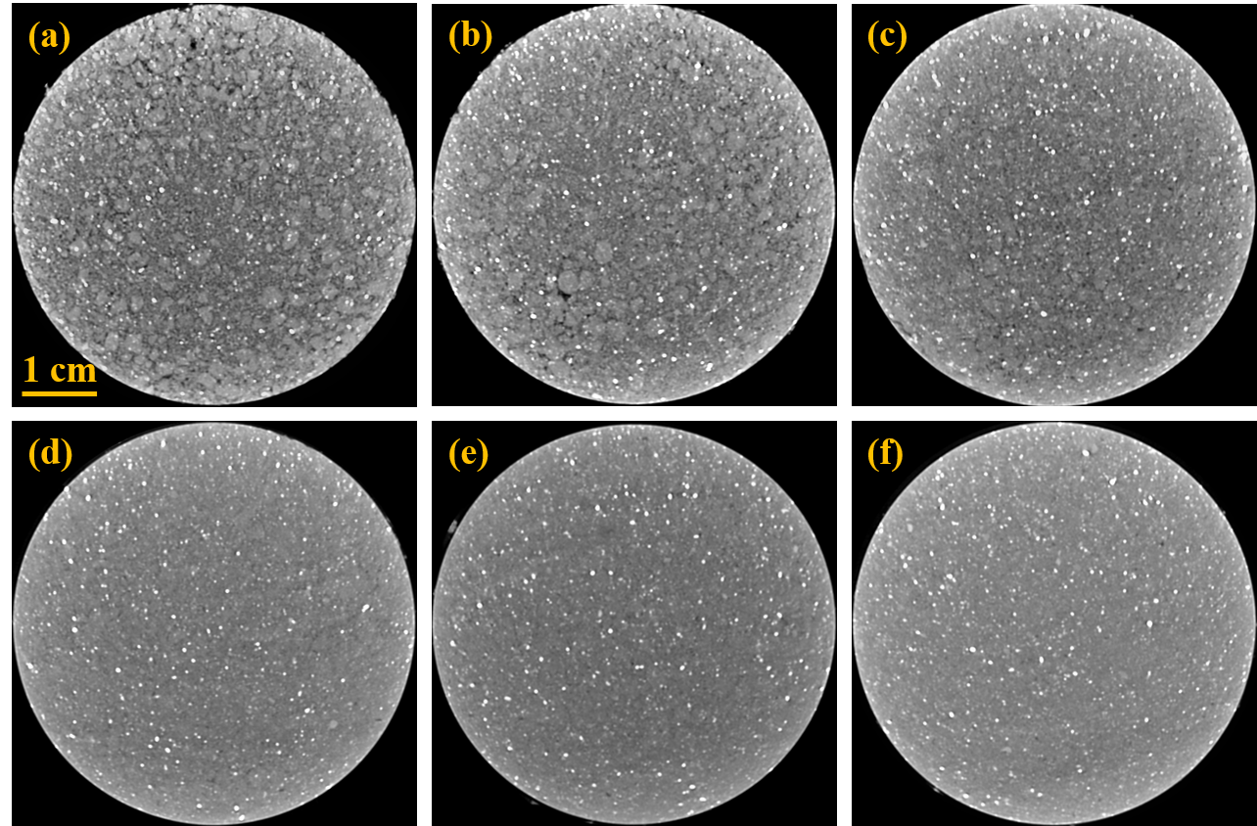

Fig. S4 Grey images of PFSC stabilized contaminated soil specimens compacted with degrees of (a) 75%, (b) 80%, (c) 85%, (d) 90%, (e) 93%, and (f) 96%. Macropores are shown in black color, and the soil textures are shown in grey color.



Fig. S5. XPS survey of PFSC stabilized contaminated soil samples compacted with degrees of (a) 75%, (b) 90%, and (c) 96%.